**Lesson 04 Demo 03**

**Generating Cards Using Microsoft Designer**

**Objective:** To generate a comprehensive greeting card for fresh bar, a company specializing in milk products, using Microsoft Designer

**Tools required:** Microsoft Designer

**Prerequisites:** NA

Steps to be followed:

1. Use Microsoft Designer to generate a greeting card

**Step 1: Use Microsoft Designer to generate a greeting card**

* 1. Open the Microsoft Designer website as shown:

<https://designer.microsoft.com/>

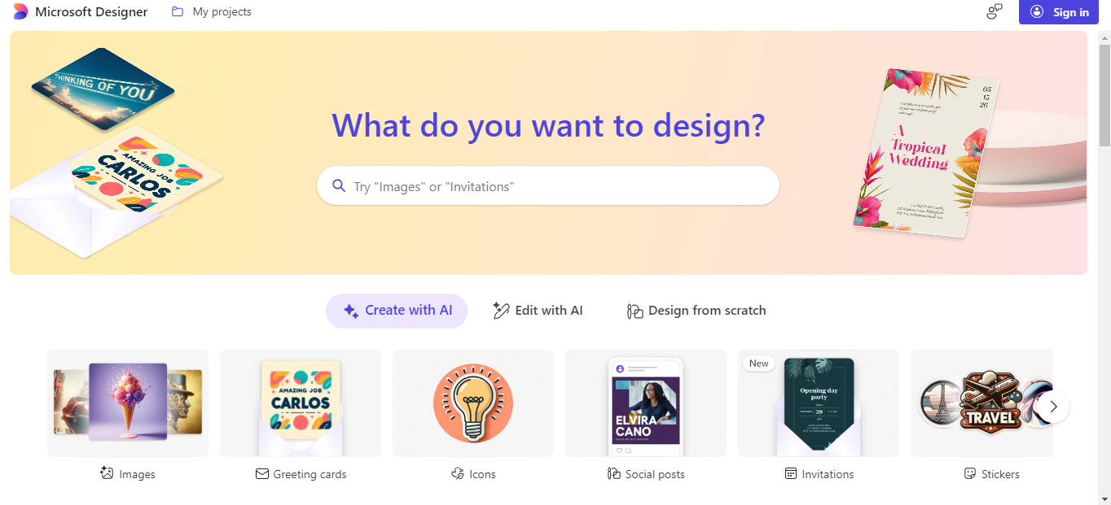

* 1. Click on **Sign in** to log in using your email id:

If required please create Microsoft account ie personal account for any future use with Microsoft or already present no need to create use existing account only.

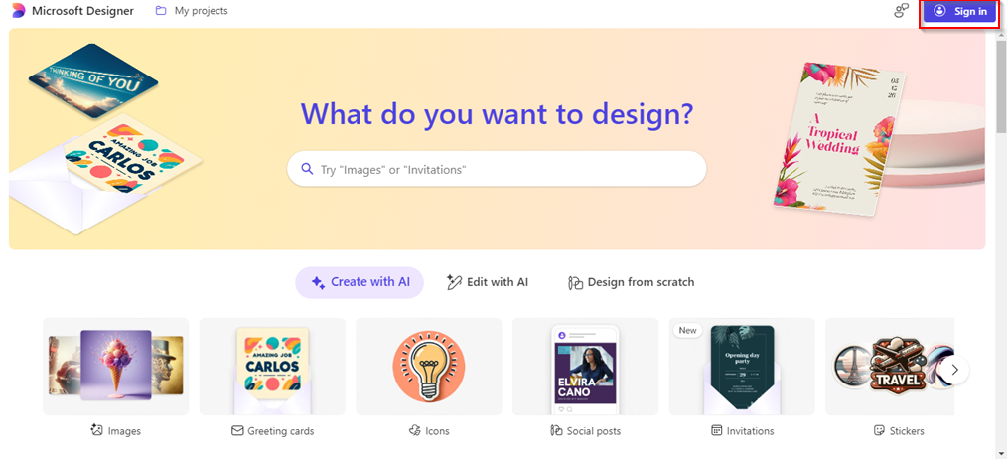

* 1. Scroll down and select any desired style of your choice from the **Make someone’s day with a unique card** section as shown:

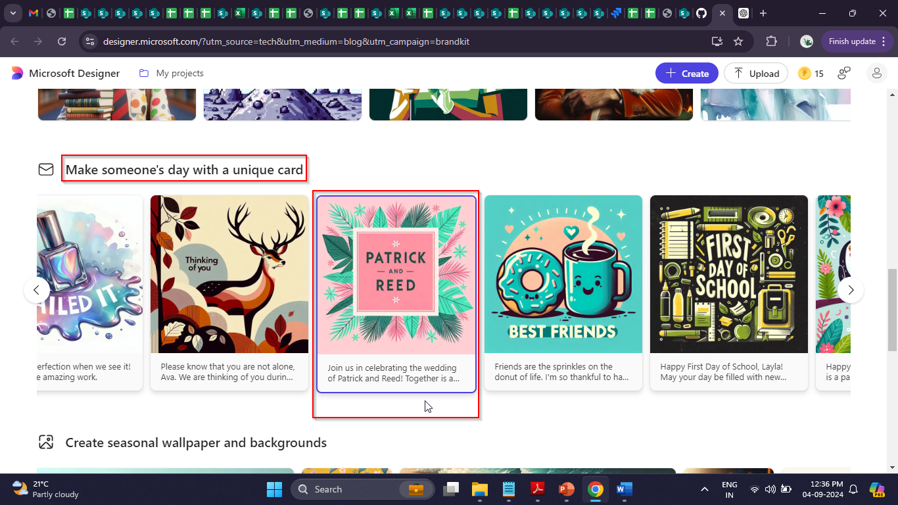

You will see the following interface:

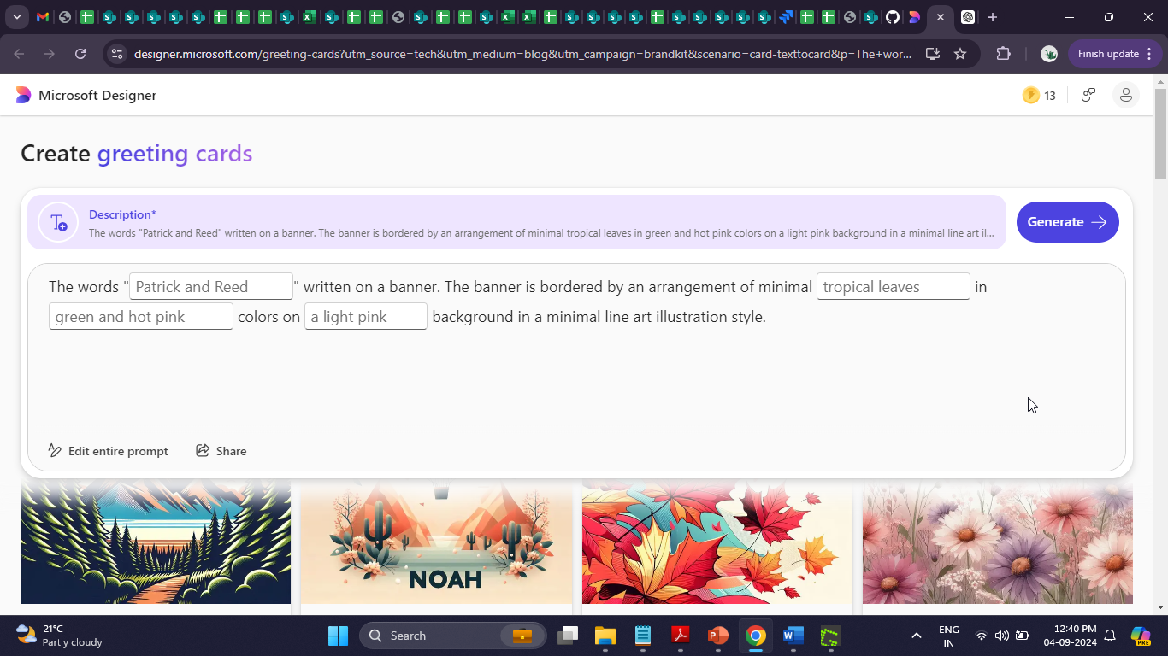

* 1. Click on **Edit entire prompt**

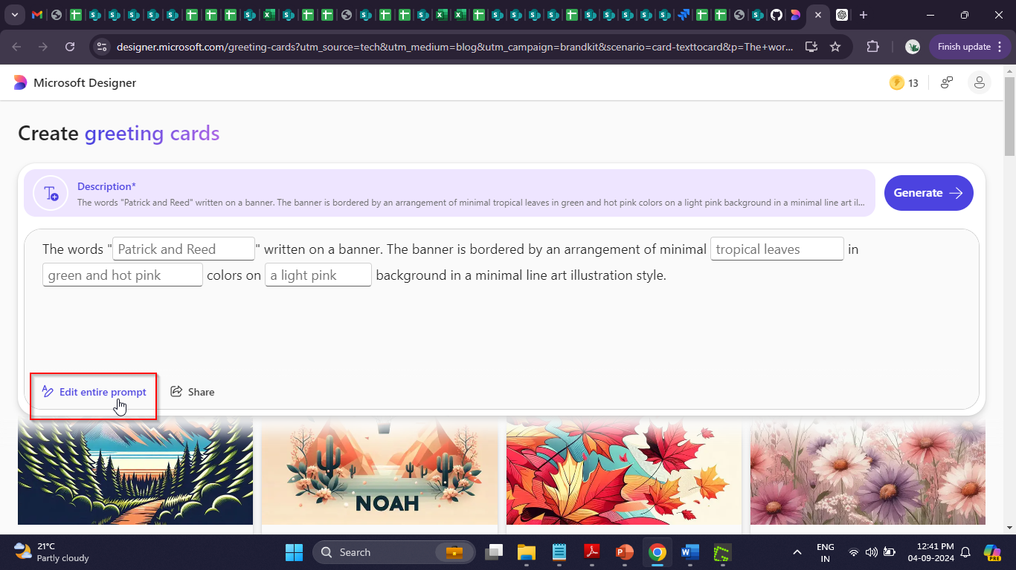

* 1. Use the following prompt to generate the card, and then click on the   
     **Generate** button:

**A milk product company with efficient supply chain management, on-time delivery, and customer support that sells milk, paneer, and milk sweets.**

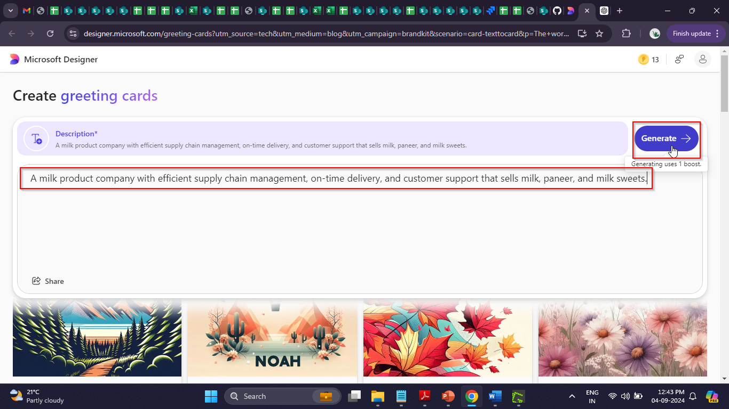

**Note**: If you get any error please switch to another browser mainly micro soft edge.

Different Cards for the given prompt are generated.

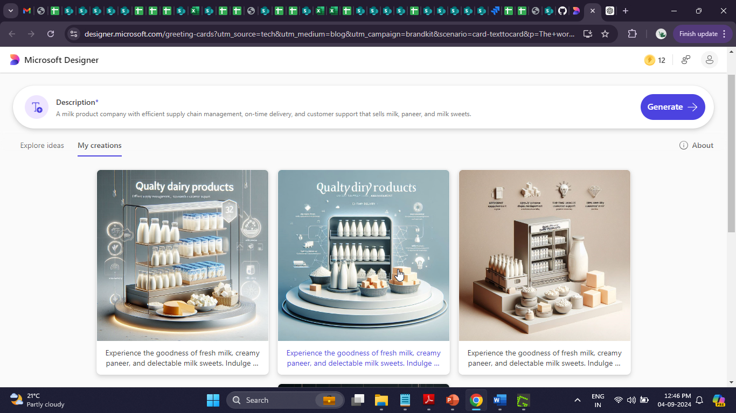

* 1. Click on the card of your choice

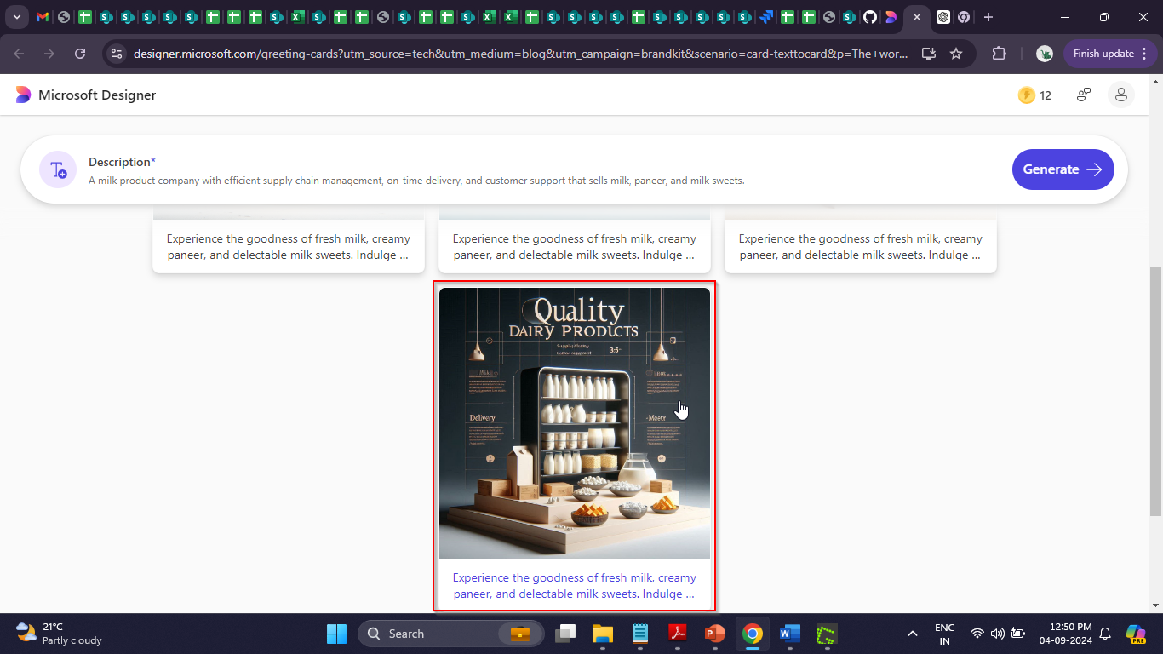

* 1. Click on the **Edit text** Button

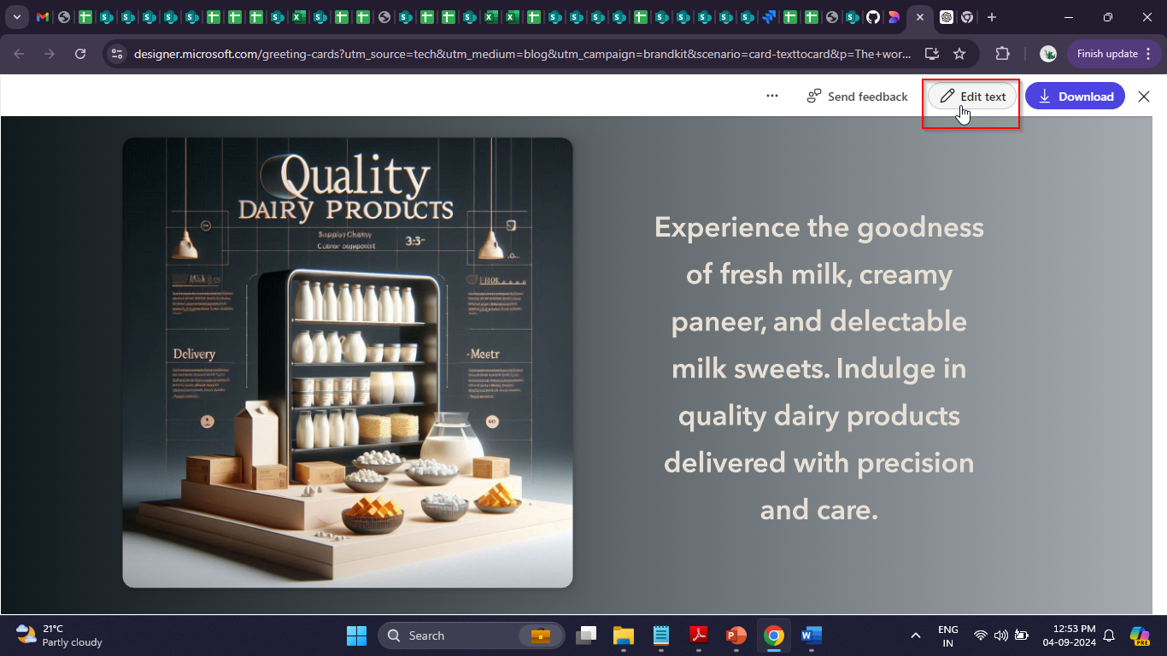

* 1. Use the following prompt in ChatGPT to generate different brand voices for   
      freshbar’s brand greeting card

**One line brand voice for freshbar company that sells milk and milk products including milk chocolate and milk sweets**

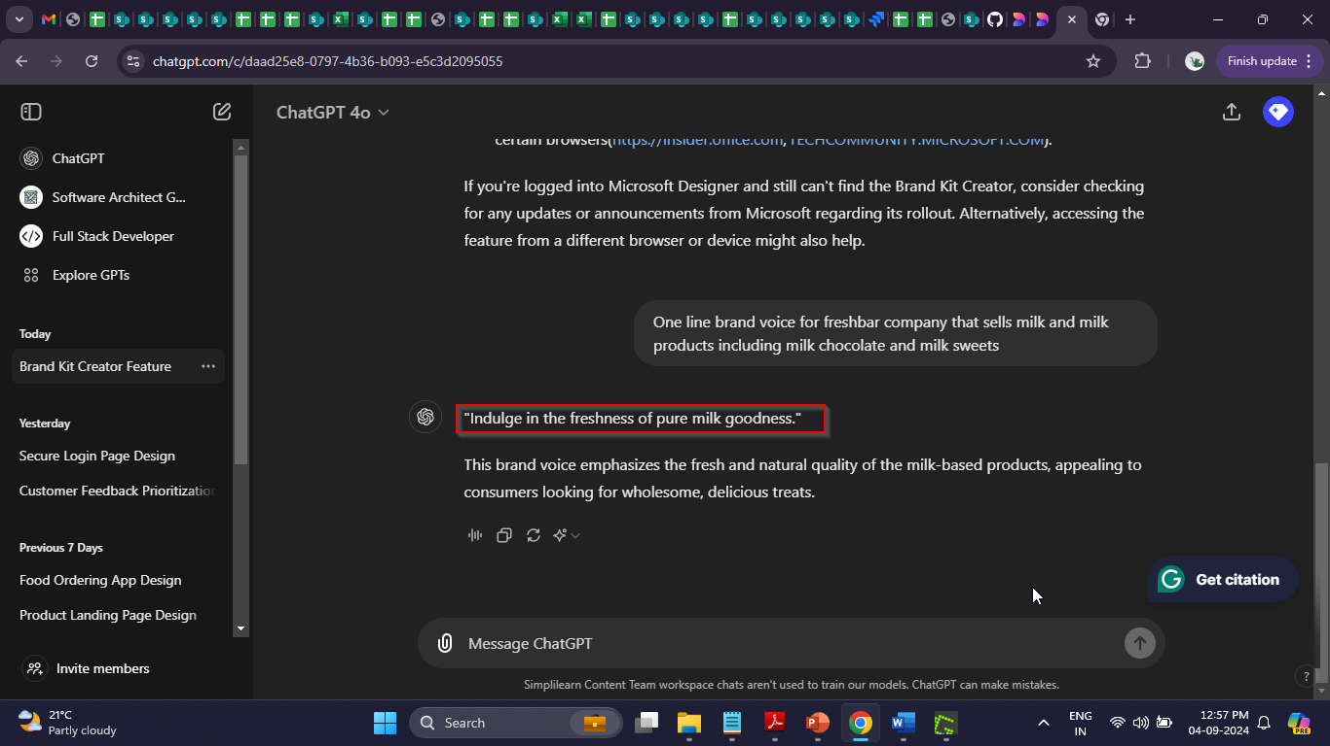

* 1. Copy the generated brand voice and replace the existing one as shown:

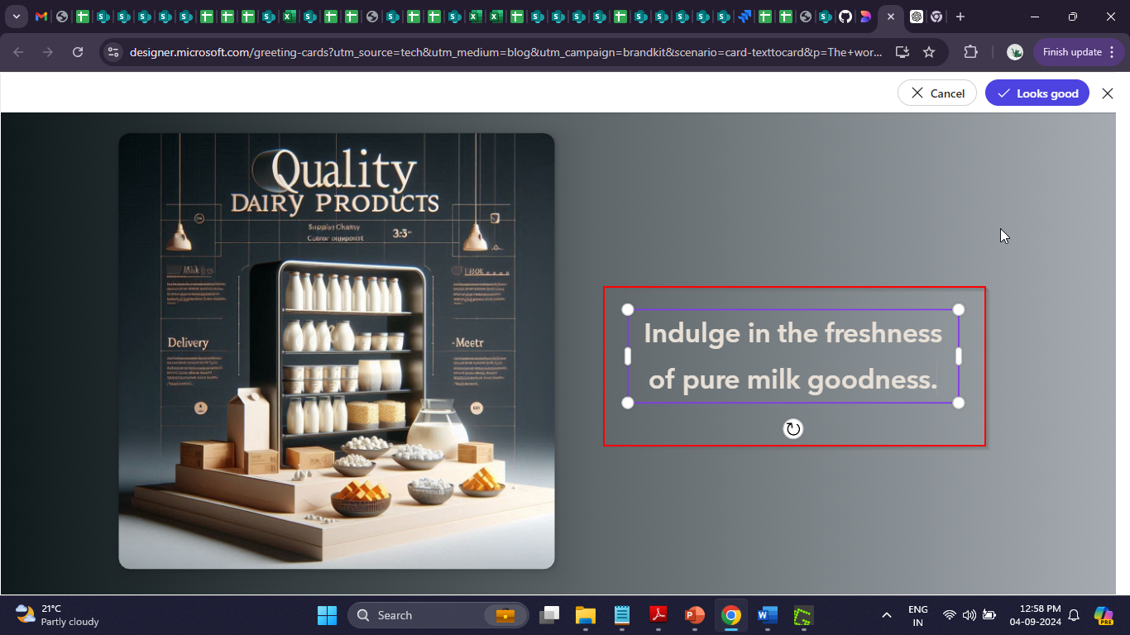

* 1. Click on **Looks good** to finalize the card

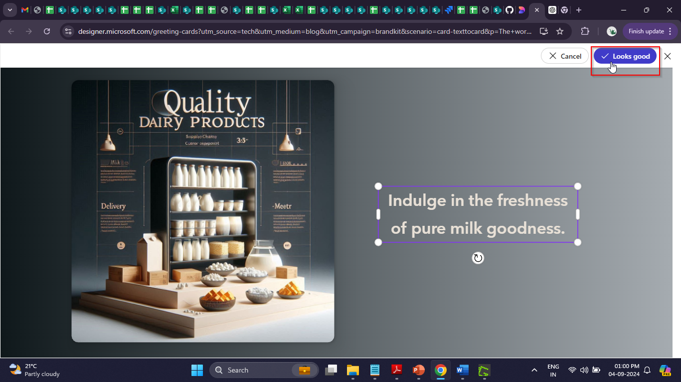

* 1. Click on the **Download** button to download the card

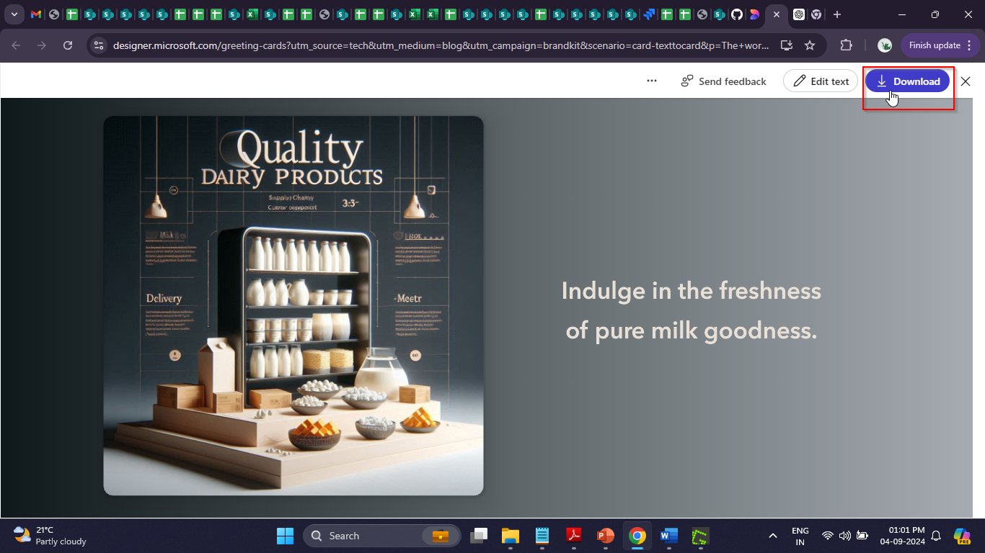

* 1. Open and verify the file, which consists of the generated card

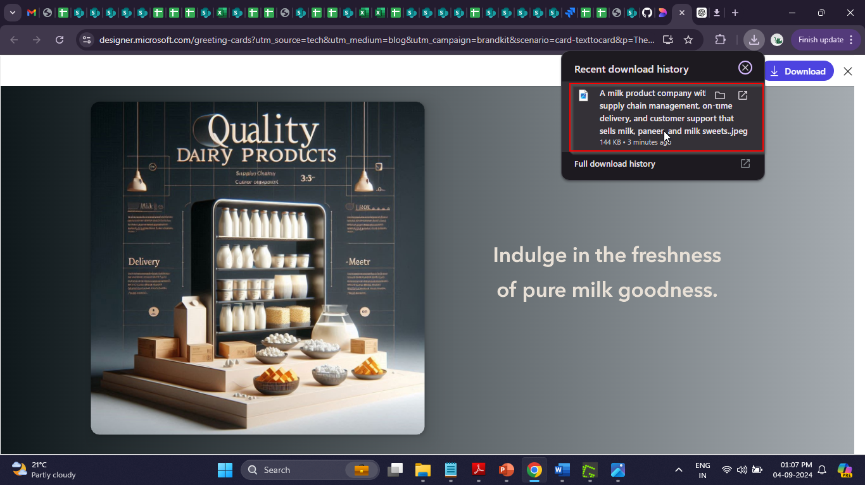

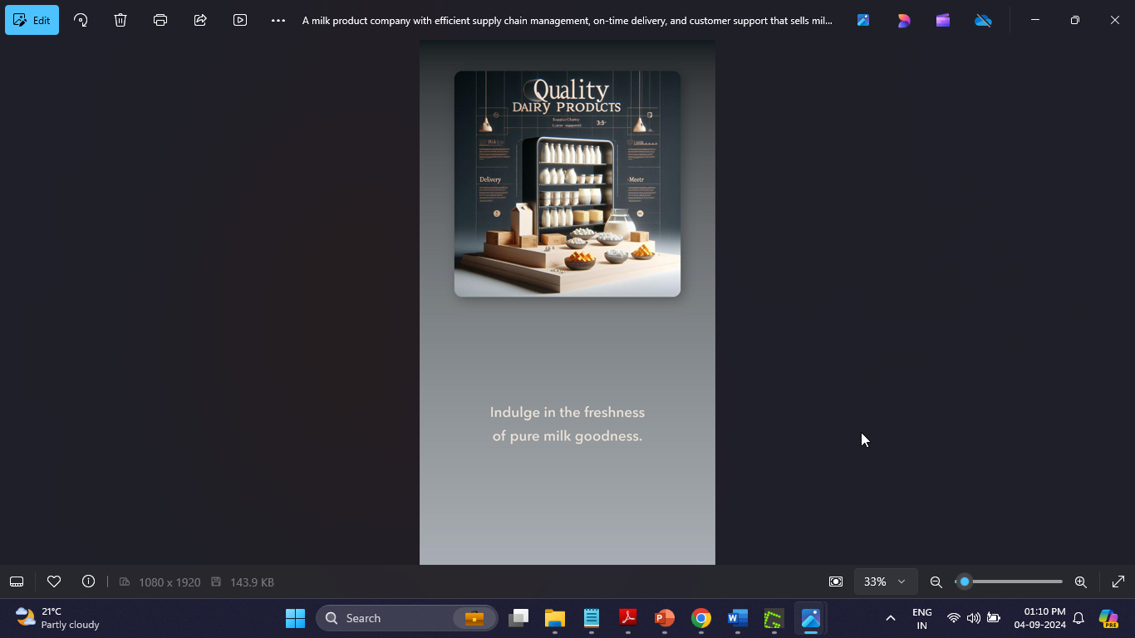

By following these steps, you have successfully generated a comprehensive greeting card for freshbar using Microsoft Designer, enhancing the company's visual identity and communication strategy.